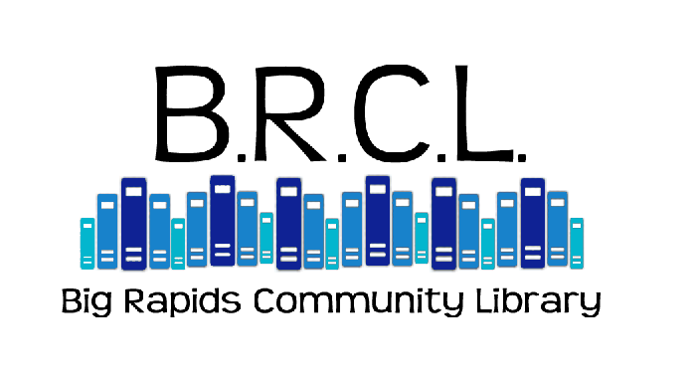
Homebound Patron Registration

Name________________________________________________________________

Date of Birth__________________________ Male______ Female_______

Address____________________________________Apt. #___________________

City____________________________Township_____________________________

Zip__________________Phone_________________Email_____________________

Emergency contact: Name______________________________Phone___________________________

Do you currently have a Big Rapids Community Library Card? Yes_______No_______

Do you have a home computer or device with Internet Access? Yes_____No________

Do you have a dog at home? Yes________No_________

The Big Rapids Community Library Homebound Delivery program is only for those individuals who are unable to travel independently. The Homebound Delivery program is not merely a book delivery program; it is an outlet for those unable to leave their homes independently to get reading material and be in contact with the library. Please consider the amount of time and consideration that goes into putting this program together for both library staff and volunteers. If you are able to come into the library independently, please do not participate in this program.

Eligibility

Please indicate the primary reason you need Homebound Library Service:

 | Physical disability |  | Illness
 | This situation is permanent |  | This situation is temporary.  NEED SERVICE UNTIL:

Service Plan
Request Only: Send me only the items that I request
Select titles for me in addition to any requests that I make (Readers Advisory)
ANY SPECIAL REQUESTS FOR TITLES NEED TO BE CALLED INTO THE LIBRARY for the Homebound Coordinator at least 10 days BEFORE YOU ARE EXPECTING THE DELIVERY. (delivery is usually during the first week of every month)

**** I give the Big Rapids Community Library permission to keep a list of materials I have borrowed in order to avoid any duplication. I understand that library records are confidential and will not be released to anyone other than the borrower.

Number of Materials

How many items would you like delivered each month?

 | 1-2 |  | 3-4 |  | 4-5

Special Instructions

I prefer regular print books.
I read only large print books.
I prefer large print books, but regular print is acceptable.
Paperback books are acceptable.
I cannot hold heavy books. Do not send books over __ pages.

ADULT: Interest Profile. Please select the areas that interest you.

 | Adult Fiction |  | Adult Non-Fiction
 | Adventure |  | Art
 | Best sellers |  | Biography
 | Christian fiction |  | Computers
 | Classics |  | Cooking
 | Crime |  | Crafts/Hobbies
 | Family stories |  | Diet
 | Fantasy |  | Exercise
 | Graphic novels |  | Gardening
 | Historical fiction |  | Health
 | Horror |  | History
 | Humor |  | Humor
 | Mystery – cozy |  | Music
 | Mystery – hard boiled |  | Nature/Animals
 | Oprah’s list |  | Personal Finance/Business
 | Romance |  | Philosophy
 | Science fiction |  | Plays
 | Short stories |  | Poetry
 | Spy / espionage |  | Politics/Current Events
 | Thriller / suspense |  | Psychology/Self-Help
 | War |  | Religion
 | Western |  | Science
 |  |  | Sports
 |  |  | Stage/Screen
 |  |  | Travel
 |  |  | True Crime
 |  |  | War

Favorite authors:
Favorite series:
Other special interests or topics:

CHILDREN: Interest Profile. Please select the areas that interest you.

 | Children’s fiction (chapter books) |  | Children’s non-fiction
 | Children’s fiction (easy readers) |  | Children’s graphic novels

Reading level:

Favorite authors:
Favorite series:
Other special interests or topics:

TEEN: Interest Profile. Please select the areas that interest you.

 | Teen fiction |  | Teen non-fiction
 | Teen graphic novels/Manga

Reading level:

Favorite authors:
Favorite series:
Other special interests or topics:

Big Rapids Community Library Homebound Library Service
Homebound Patron Release Form

POLICY: It is the policy of the Big Rapids Community Library to provide library services to the residents of the City of Big Rapids and the contracting townships of Barton, Big Rapids, Colfax, Grant, Green, and Norwich who are unable to come to the library. Trained volunteers will visit homebound residents on a monthly schedule to deliver new materials, and to pick up any library materials being returned. Library staff will make library selections based on customer preferences previously indicated.

By my signature below, I hereby agree to hold harmless and release the Big Rapids Community Library, its officers, agents, employees, and representatives from any loss, liability, claim, suit or judgment that may arise out of or in conjunction with the Homebound Library Service.

I understand that the library staff will select materials for my use, check the materials out to me for a four-week loan period, and that the library will arrange to have a volunteer deliver the materials to my home on a scheduled basis.

Further, I understand that the volunteer assigned will be available only for scheduled visits to deliver books. They will not provide assistance with activities of daily living or advice on financial or personal matters.

I understand that the program is supervised by the Library staff and that any problems or conflicts with the volunteer are to be reported to staff. I also understand that I may become ineligible for this program if I do not abide by the guidelines set forth.

__________________________________________________________ __________________
Signature Date

